**5) Create Cloud Function and deploy it.**

Step 1 : Create a function in Cloud function with http trigger

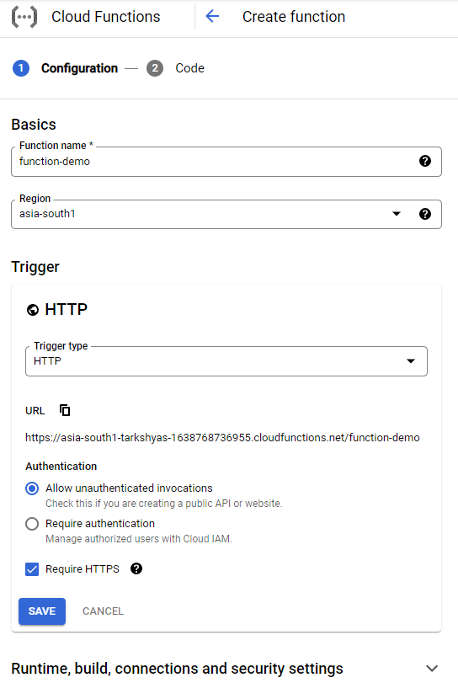

Step 2 : Set runtime to python and deploy the code

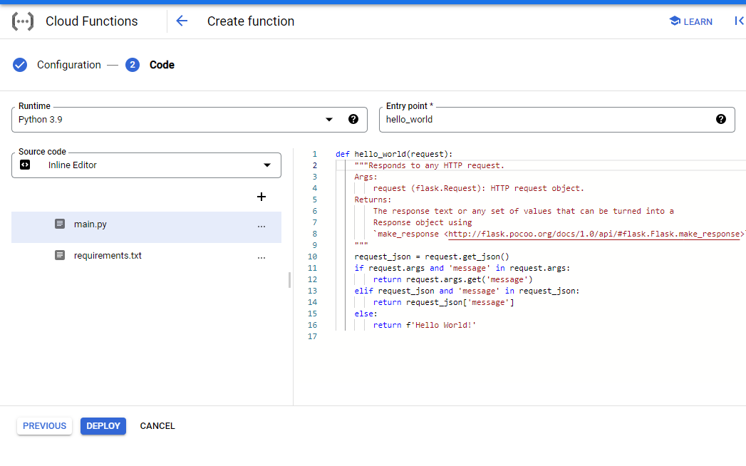

Step 3 : Thus the function is deployed and now test the function

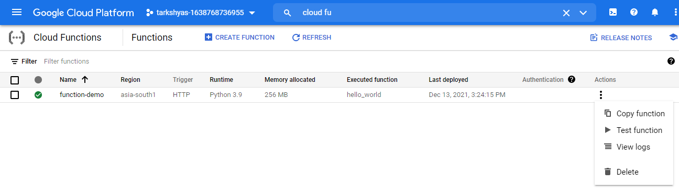

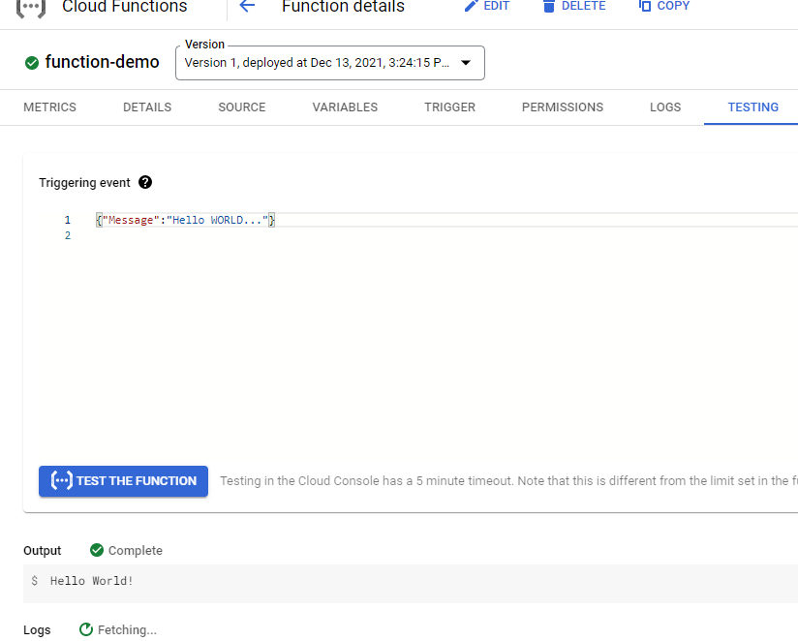

Step 4 : Now go to the trigger and we can see an URL created which leads to the result of deployed function ie, Hello World!

